PLANTS & FLORAL RENTAL SERVICE
^{FORM NO.} E5
Item | Description of Services | Advanced Rate  (SGD) | Standard Rate  (SGD) |  | Qty | Cost
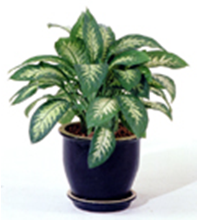 | Dracaena  - 3ft & Below  - 4ft to 5ft | 18.00  24.00 | 23.40  32.10
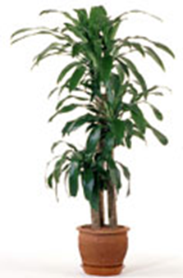 | Dieffeubachia  - 3ft & Below  - 4ft to 5ft | 18.00  24.00 | 23.40  32.10
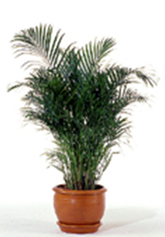 | Potted Palm  - 4ft to 5ft  - 6.5ft to 8ft | 18.00  22.00 | 23.40  28.60
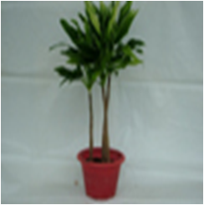 | Cordyline  - 3ft & Below  - 4ft to 5ft | 18.00  24.00 | 23.40  32.10
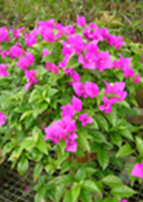 | Bougainvillea  - 3ft & Below | 24.00 | 32.10
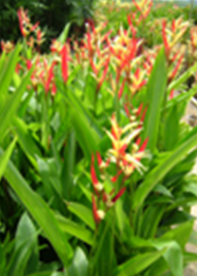 | Heliconia  - 3ft & Below | 24.00 | 32.10
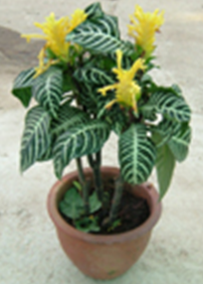 | Aphelandra  - 3ft & Below | 28.00 | 36.40
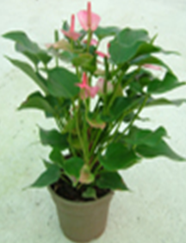 | Anthurium  - 3ft & Below | 28.00 | 36.40
* Singapore domicile companies will be subjected to 7% Goods & Services Tax (GST)  * Bank charge ($35.00 or $50.00) will be applicable for overseas companies |  |  |  | Total Cost Before GST/Bank Charges

